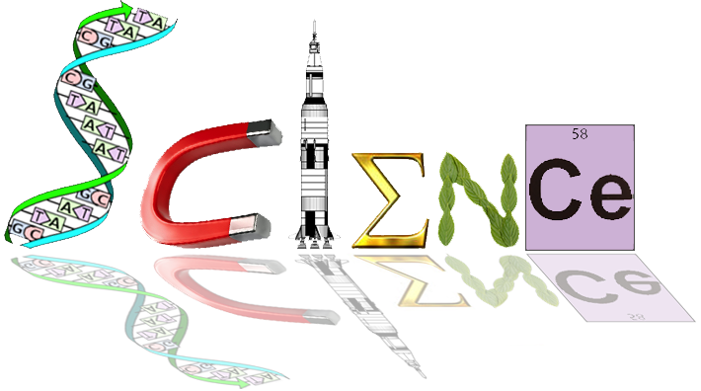

**ANSWERS**

**Yr 12 ATAR Human Biology**

**Endocrine and Nervous Control**

**Test 1 (Task 3), 2018**

**/60**

**Multiple Choice Section: (20 marks)**

1. The cerebral cortex is mainly concerned with which of the following?
2. connecting the left and right hemispheres
3. conscious sensory awareness and voluntary movement
4. control of the endocrine system
5. control of both the parasympathetic and sympathetic nervous systems
6. Which of the following statements concerning a spinal reflex is NOT correct?
7. it is a rapid process
8. it is involuntary
9. it can bypass the brain
10. it can occur in a different manner each time
11. Within the nervous system there are special structures that help to protect the system from injury. The name of the membranes that surround the central nervous system is the:
12. meniscus
13. meninges
14. medulla
15. myelin
16. People who have suffered physical damage to the cerebellum would be expected to show symptoms such as:
17. a low intelligence
18. uncoordinated jerky movements
19. a lack of autonomic nervous system functioning
20. no memory
21. The autonomic nervous system is responsible for which of the following?
22. sleeping and waking cycles
23. voluntary smooth muscle functioning
24. involuntary smooth muscle functioning
25. voluntary skeletal muscle functioning

The information below describes changes that occur within the human body

1. dilation of pupils
2. increased salivation
3. increased secretion from the sweat glands
4. increased heart rate
5. decreased levels of adrenalin
6. dilation of blood vessels in the skeletal muscle
7. Which of the changes described above occur as a result of stimulation of the sympathetic nervous system?
8. i,iii,v and vi
9. i, ii, iii and v
10. i, iii, iv and vi
11. ii, iv, v and vi
12. The effectors associated with negative feedback models are:
13. the nervous and endocrine systems
14. the body fluids
15. glands and muscles
16. all body tissues
17. The ________ contains centres for heartbeat, breathing, and blood pressure.:
18. hypothalamus
19. cerebellum
20. medulla oblongata
21. spinal cord

1. Which of the following is NOT produced by the anterior pituitary gland?
2. antidiuretic hormone
3. thyroid stimulating hormone.
4. growth hormone.
5. prolactin.
6. Which of the following statements is true of hormones?
7. Hormones are stable, long-lasting chemicals released from glands
8. All hormones are lipid-soluble
9. Hormones are chemical messengers that are released into interstitial fluid
10. Hormones are short-lasting and function in localised areas of the body
11. When the hormone cortisol reaches a target cell, it enters the cell and combines with a receptor protein inside the cell. The combined substance enters the nucleus, where it activates genes to produce a protein. Thus, cortisol is a:
12. water soluble amine
13. water soluble steroid
14. lipid soluble amine
15. lipid soluble steroid

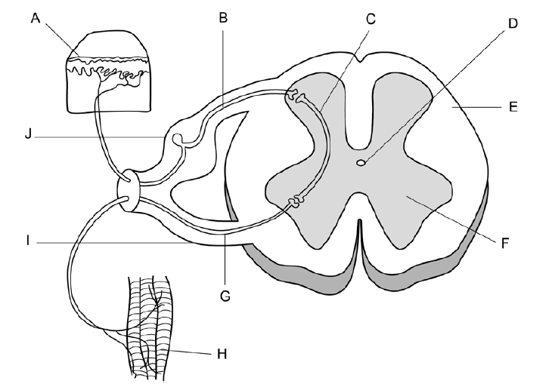

1. Which of the following statements relating to the above diagram of the spinal reflex arc is correct?
2. A stimulus is detected by the receptors labelled ‘H’ and transmitted through the sensory neuron labelled ‘G’
3. The motor neuron is labelled ‘G’ and is located in the ventral root labelled ‘I’
4. The interneuron is labelled ‘C’ and is located in the white matter labelled ‘F’
5. A stimulus is detected by the receptors labelled ‘A’ and transmitted through the motor neuron labelled ‘B’
6. The neuron labelled ‘B’ in the diagram can be described as an:
7. afferent neuron carrying information toward the spinal cord
8. efferent neuron carrying information away from the spinal cord
9. efferent neuron carrying information toward the spinal cord
10. afferent neuron carrying information away from the spinal cord

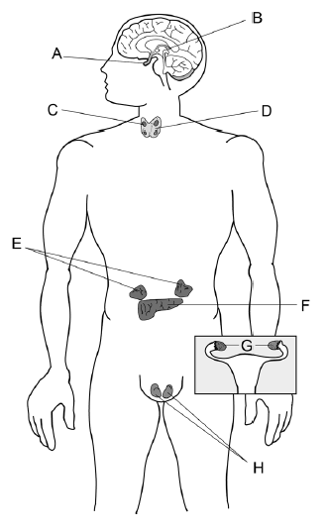

1. Which of the following options correctly matches a label with a hormone it secretes:
2. A – melatonin
3. D = growth hormone
4. E = epinephrine
5. H = oxytocin
6. In a person with normal thyroid function, low levels of thyroxin in the blood would result in:
7. increased metabolic rate and would involve feedback from the anterior pituitary
8. increased metabolic rate and would involve feedback from the posterior pituitary
9. decreased metabolic rate and would involve feedback from the anterior pituitary
10. decreased metabolic rate and would involve feedback from the posterior pituitary
11. Throughout the peripheral nervous system _______________ cells produce myelin, whereas ___________________ provide myelin in the central nervous system.
12. astrocytes, Schwann
13. Shwann, oligodendrocytes
14. Shwann, neurilemma
15. neurilemma, astrocytes
16. Which of the following structures is the smallest?
17. nerve
18. neuron
19. nerve fibre
20. ganglion
21. At resting potential, the ion distribution inside and outside of a neuron is such that __________ ions are most abundant on the outside of the cell, while __________ ions are most abundant on the inside of the cell.
22. potassium; sodium
23. sodium; potassium
24. calcium; phosphate
25. sulfate; potassium

**Short Answer: (20 marks)**

* + - 1. Distinguish the autonomic nervous system from the somatic nervous system. (2 marks)

1 mark – The autonomic nervous system is involuntary, controlling critical muscles such as those in the heart, alimentary canal.

1 mark – The somatic nervous system relates to voluntary function, including skeletal muscles.

* + - 1. Define the term refractory period, in relation to nerve impulse. (2 marks)

1 mark – This is the period in which the axon (or a section of axon) is hyperpolarised following depolarisation

1 mark – during this time, it is not possible for another action potential to move along this section of axon.

* + - 1. Explain why scientists classify neurons into both functional and structural types. (2 marks)

1 mark – Functional types relate to the structure to which a neuron conducts its nerve impulse (sensory (afferent), interneuron and motor (efferent) neurons)

1 mark – However, structural types relate to the appearance and number of extensions of the neuron (pseudo unipolar, bipolar, and multipolar)

1. The diagram below shows the relationship between the hypothalamus and the pituitary gland.





Describe the process leading to secretion of hormones from the anterior lobe into the bloodstream. (3 marks)

Explain why the posterior lobe is **not** considered to be a true endocrine gland. (2 marks)

Use the two hormones released by the anterior lobe of the pituitary gland to complete

the following table**. (4 marks)**

|  |  |  |
| --- | --- | --- |
| **Hormone** | **Target Cells/Organ** | **Function** |
| Adrenocorticotrophic  hormone (ACTH) |  |  |
| Luteinizing hormone  (LH) |  |  |

1 mark – The anterior sits in front of the posterior, and is connected to the hypothalamus via blood vessels

1 mark – The posterior is only connected to the hypothalamus via nerve fibres

1 mark – Thus, functionally, the anterior produces and secretes hormones, whereas the posterior lobe secretes hormones. These are produced by the hypothalamus.

1 mark – The glands also differ in the number and type of hormones they produce, with the anterior producing many more (eg. TSH, GH, LH, FSH etc) than the posterior (oxytocin, ADH).

1. Clarify the term ‘saltatory conduction’ and explain where you would expect this to occur in the spinal cord. (2 marks)

1 mark – Saltatory conduction is the very fast propagation of action potentials along myelinated axons, which appear to ‘jump’ from one node of Ranvier to the next node.

1 mark – Saltatory conduction tends to occur on the periphery of the spinal cord as the central part consists of unmyelinated grey matter.

1. 

Alzheimer’s disease is a form of dementia that can cause memory loss, confusion and

mood swings. Given these symptoms of Alzheimer’s disease, which part of the brain

1. (labelled A-D) above would you expect to be most affected by this disease? (1 mark)Although different diseases, Alzheimer’s disease and Parkinson’s disease are similar in that they both affect the brain. There are also similarities in the causes and effects of these diseases. State one such similarity between Alzheimer’s disease and Parkinson’s disease.

(1 mark)

1 mark – Any correct similarity

Eg. due to a neurotransmitter deficiency; late onset/age of onset; cognitive/memory impairment

1. Several hormones are produced by the gonads. Name one of these hormones and state the target organ it influences. (2 marks)

1 mark – Any correct hormone

1 mark – Any correct target organ

**SECTION C: EXTENDED ANSWER (___/20 marks)**

Answer ALL QUESTIONS on the lined paper provided. DO NOT WRITE IN PENCIL.   
Your answer may take the form of:

• Appropriate graphic organisers e.g. a table

• Clearly labelled and annotated diagrams

• A list of points, with sentences which link them

Up to two marks may be deducted for poorly constructed answers.

(a) Aspirin helps reduce pain because it inhibits the synthesis of neurotransmitters called prostaglandins. Outline the events involved in an electrochemical nerve impulse travelling along one myelinated cell and passing to another, including the generalised role of neurotransmitters at the junction between two neurons. (8 marks)

Any 8 of the following:

1 mark – depolarisation involves the disturbance and opening of many sodium gates, resulting in an increasingly positive charge within the cell membrane

1 mark – this only occurs at the nodes of Ranvier (as the myelin blocks access to the cell membrane) and produces saltatory conduction

1 mark – Following depolarisation at the nodes of Ranvier, repolarisation occurs, during which sodium gates shut and potassium gates open

1 mark - the refractory period (hyperpolarisation) prevents the action potential from moving backwards

1 mark – the action potential reaches the presynaptic terminal, disturbing calcium gates, resulting in a release of calcium ions

1 mark – this disrupts vesicles of neurotransmitters, which move to the cell membrane and undergo exocytosis of the neurotransmitters into the synaptic space

1 mark – these neurotransmitters then attach to receptors on the post-synaptic terminal of the next cell, provoking another electrical impulse.

1 mark – disturbance of cell membrane and opening of sodium gates

1 mark – depolarisation begins slowly until the threshold is met (-55mV)

1 mark – once the threshold is met, the action potential rapidly travels down the axon (from the axon hillock)

Add in:

1mark – unsused neuroreceptors bind to autoreceptors on pre synaptic terminal to prevent further neurotransmitter release.

1mark – Neurotransmitters disposed of by enzyme degradation or by reuptake

(b) Compare and contrast nervous and endocrine control, and explain why the hypothalamus is critical to both systems. (12 marks)

5 marks – comparisons between the systems

Any five of the following:

* Both function to maintain homeostasis and life
* Can both affect all other body systems
* Share structures such as the hypothalamus
* Can both act on endocrine glands
* Both use hormones such as epinephrine, oxytocin, vasopressin or ADH (either to affect target organs or as neurotransmitters)

5 marks – contrasts between the systems

* Nature of message
* Transport of message
* Cells affected
* Time taken to respond
* Duration of response

2 marks – explanation of the hypothalamus

Any two of the following:

1. The hypothalamus is critical to the endocrine system as it not only produces hormones, but also stimulates or inhibits the production of hormones by other glands.
2. However, it is also integral to the nervous system, particularly the autonomic division.

Or

1. The hypothalamus is the link between the endocrine and nervous system, and is integral to enabling these systems to communicate and thereby maintain homeostasis.